



Python Program Demonstrating Hierarchical Inheritance
LAB MANUAL

Disclaimer: The content is curated from online/offline resources and used for educational purpose only
Python Program Demonstrating Hierarchical Inheritance

Objectives:
- To understand and implement hierarchical inheritance in Python using classes.
- To create a base class Person that holds personal information.
- To create multiple derived classes Employee and Manager that inherit from Person but have their own specific attributes and methods.
- To demonstrate how multiple derived classes can inherit from a common base class and add unique functionality.
Problem Statement:
The task is to design a system that manages employee and manager data using hierarchical inheritance. The base class Person will store common details such as name and age. Two derived classes, Employee and Manager, will inherit from Person and add specific attributes such as employee_id, salary, department, and team_size. The program will demonstrate how both classes can share common attributes from the base class while maintaining their unique functionality.
Procedure:
Task 1: Define the Base Class Person
Task 2: Define the Derived Class Employee
Task 3: Define the Derived Class Manager
Task 4: Instantiate Objects from Employee and Manager Classes

Code:
Task 1: Define the Base Class Person
The Person class is the base class and contains common attributes like name and age.
The display_personal_details() method prints the name and age of the person.
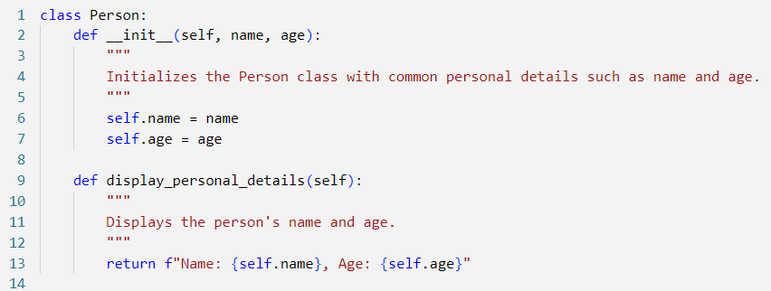

Task 2: Define the Derived Class Employee
The Employee class inherits from Person and adds new attributes employee_id and salary specific to employees. The display_employee_details() method prints the personal details along with employee-specific information like employee_id and salary.

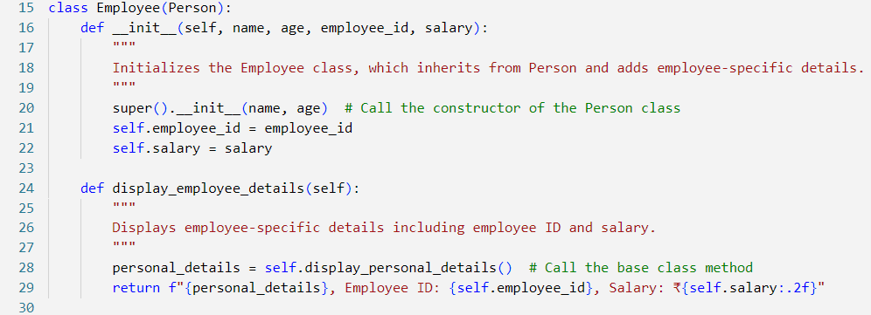

Task 3: Define the Derived Class Manager
The Manager class also inherits from Person but adds different attributes specific to managers, such as department and team_size. The display_manager_details() method prints the personal details and manager-specific information like department and team size.
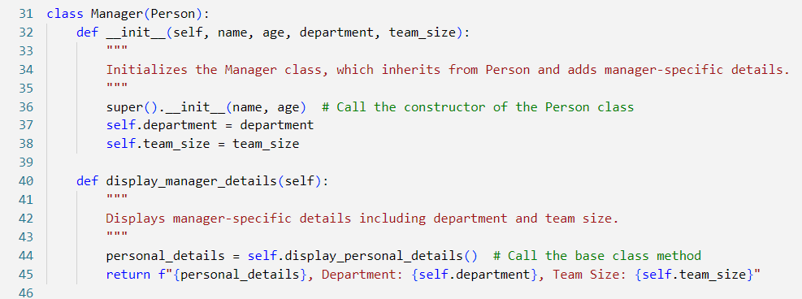

Task 4: Instantiate Objects from the Manager Class
An object employee is created from the Employee class with the name "Employee1", age 30, employee ID "E12345", and salary of ₹50,000. Another object manager is created from the Manager class with the name "JManager", age 40, department "Sales", and team size of 12. Both objects print their respective details using their own methods.

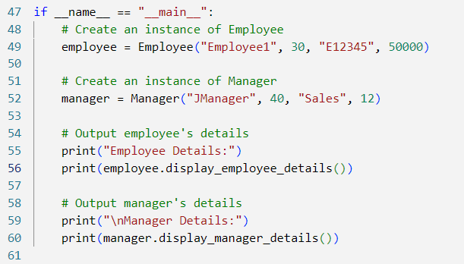

Output:
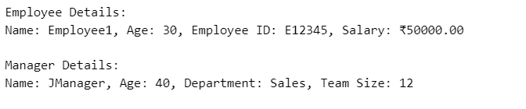

This program demonstrates hierarchical inheritance, where multiple classes (Employee and Manager) inherit from a common base class (Person). Each derived class adds specific functionality related to employees and managers while sharing common attributes and methods from the Person class.

